# Tugas Pemrograman Berorientasi Objek



**Muhamad Salman Adhim Baqy**

**A11.2020.12641**

**Fakultas Ilmu Komputer**

**Program Studi Teknik Informatika**

**Universitas Dian Nuswantoro**

**2022**

1. Library

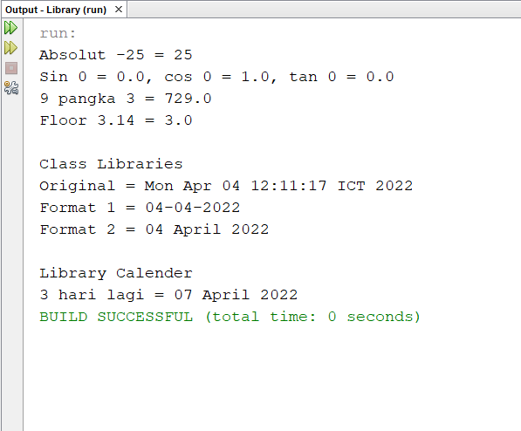

|  |
| --- |
| /*  * To change this license header, choose License Headers in Project Properties.  * To change this template file, choose Tools | Templates  * and open the template in the editor.  */  package library;  import java.text.SimpleDateFormat;  import java.util.Calendar;  import java.util.Date;  /**  *  * @author adhim  */  public class Library {  /**  * @param <Date>  * @param args the command line arguments  */  public static void main(String[] args) {  // TODO code application logic here  System.out.println("Absolut -25 = " + Math.abs(-25));  System.out.println("Sin 0 = " + Math.sin(0) + ", cos 0 = " + Math.cos(0) +", tan 0 = " + Math.tan(0));  System.out.println("9 pangka 3 = "+ Math.pow(9, 3));  System.out.println("Floor 3.14 = " + Math.floor(3.14));  System.out.println("\nClass Libraries");  Date tanggal = new Date();  System.out.println("Original = "+ tanggal);  SimpleDateFormat sdf1 = new SimpleDateFormat("dd-MM-yyyy");  SimpleDateFormat sdf2 = new SimpleDateFormat("dd MMMM YYYY");  System.out.println("Format 1 = "+ sdf1.format(tanggal));  System.out.println("Format 2 = "+ sdf2.format(tanggal));  System.out.println("\nLibrary Calender");  Calendar cal = Calendar.getInstance();  cal.add(Calendar.DATE, 3);  Date tigaHariLagi = cal.getTime();  System.out.println("3 hari lagi = "+ sdf2.format(tigaHariLagi));  }    } |

1. Inherited Fundamental

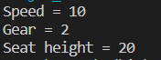

Bicycle.java

|  |
| --- |
| public class Bicycle {      int speed = 0;      int gear = 0;      void changeGear(int newValue){          gear += newValue;          System.out.println("Gear = "+ gear);      }      void speedUp(int increament){          speed += increament;          System.out.println("Speed = "+ speed);      }    } |

mountainBike.java

|  |
| --- |
| public class mountainBike extends Bicycle{      int seatHeight;      public void setHeight(int newValue){          seatHeight = newValue;          System.out.println("Seat height = "+ seatHeight);      }      public static void main(String[]args) {          mountainBike mb = new mountainBike();          mb.speedUp(10); // method dari superclass          mb.changeGear(2); // method dari superclass          mb.setHeight(20); // method dari dia sendiri atau subclass      }  } |